Installing the VBA EDAPT Report Formatter in Microsoft Word
- Open Word
- Press Alt+F11 to open the VBA Developer Window
- In the Project Browser (Top Left Column), under “Normal,” right-click “Modules,” Insert “New Module”
- Click on the Module
- In the Properties window (Bottom Left Column), Rename the Module from “Module1” to “EDA”
- In the Project Browser (Top Left Column), double-click “EDA”
- Paste the code from the attached file “EDA_report_vba.vb” into the window.
- Click Save.

Here is what your screen should look like:
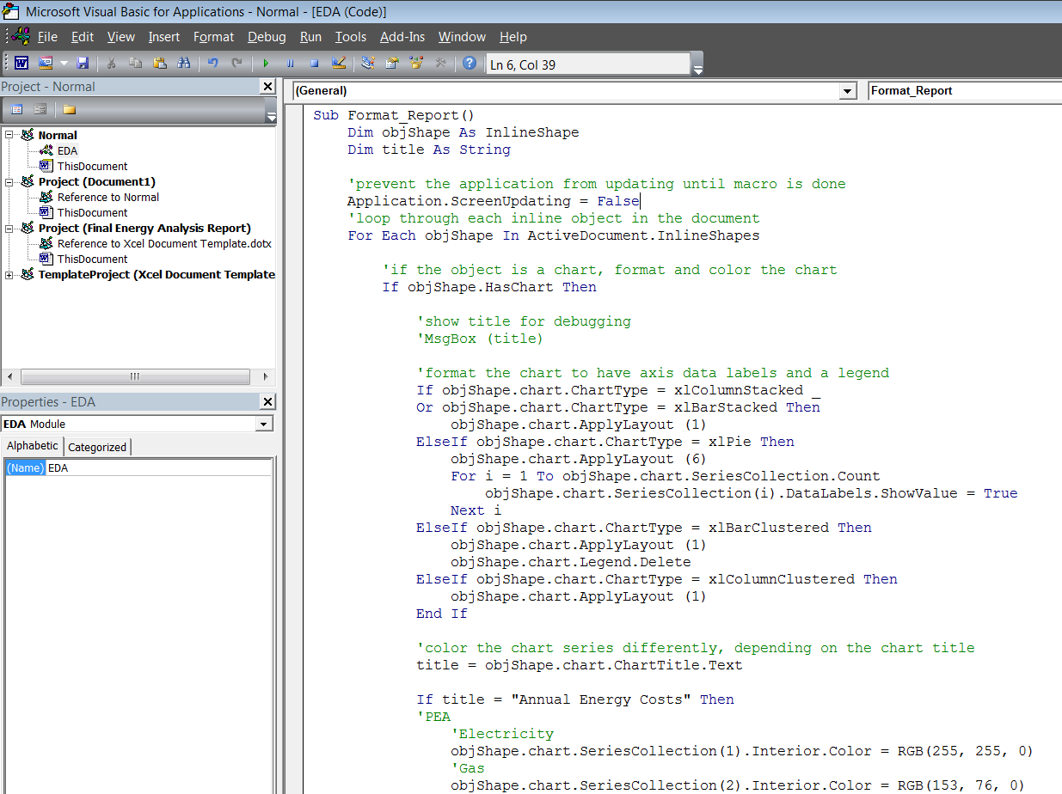

- Close the VBA Developer Window.
- In Word>File>Options>Quick Access Toolbar, Choose Commands From>Macros.
- Select “Normal.EDA.Format_Report.”
- Click “Add” to move it into the Right Column then click “Save.”

- You should now see a little icon in the top bar (see screenshot below)
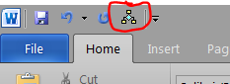
- When you open any EDAPT report, clicking on this button will run the macro and format the charts (colors, formats). If you don’t like the colors/formats, you can use Alt+F11 to open the VBA Developer Window and change it however you like.

